Student Assessment Reports (SARs)

These will be sent home to parents 3 times a year for students in years 9-13 and twice a year for our Year 7 and 8 students. The schedule for this can be accessed via the school website.

It is important that both school and parents view your child’s progress as a journey. Small steps every term, whilst building knowledge and developing skills, is the key to GCSE success. Students are not expected to move up the scale quickly. Although the highest possible grade is 9, the average grade for students at the end of Y11 is 5, progress towards this should be steady and secure over time. Each student’s progress will be compared to a flight path, which is based on their own abilities.

We believe that this approach has many benefits:

- It encourages all students to stretch themselves.
- The 9-1 scale is linked to GCSE grades; therefore it is easy to understand.
- It is simple for teachers, students and parents to monitor progress over time. As students are measured against the same criteria from Year 7 through to Year 11, we can clearly see the progress each individual is making in all subjects. Students who need stretching further, or who need more support, are easier to identify.
- The same assessment language is used across the School, making it easier for students to understand what they need to do to move on, and for parents to be involved in their child’s progress.

For Years 9, 10 and 11 SARs

In each subject, teachers will make a GCSE prediction based on all the available evidence. This prediction will be colour coded on the SAR to reflect what progress the student is making towards their target as detailed below.
- Blue Excellent - is working above expected standard
- Green Good – is working at expected standard
- Amber Requires improvement - is working below expected standard
- Red Serious Concern – is working well below expected standard
In addition, both target grades and predicted grades will be shown.

Please note that parents and students should be aware that target grades are a realistic goal and can go up based on excellent performance.

(See exemplar report at the end of this document)

Teachers also report on:
- Attitude to Learning (see descriptors below).
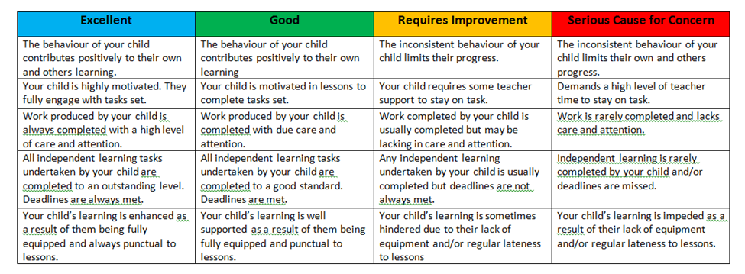

- Attendance (see descriptors below).
Outstanding If attendance is 100%,
Good If attendance is equal to or greater than 96%
Requires Improvement If attendance is less than 96%
Serious Concern if attendance is less than 90%

- Green cards, Yellow cards and Red cards
The numbers of Green cards, Yellow cards and Red cards issued along with the year group averages will be shown for each assessment report.

Sample Student Assessment Report (SAR)

