Student Assessment Reports (SARs)

These will be sent home to parents 3 times a year for students in years 9-13 and twice a year for our Year 7 and 8 students. The schedule for this can be accessed via the school website.

It is important that both school and parents view your child’s progress as a journey. Small steps every term, whilst building knowledge and developing skills, is the key to A level success. Students are not expected to move up the scale quickly. Progress towards their target grade should be steady and secure over time.

Year groups 12/13

In each subject, teachers will make an A Level prediction based on all the available evidence. This prediction will be colour coded on the SAR to reflect what progress the student is making towards their target as detailed below.
- Blue Excellent - Is working above expected standard
- Green Good – is working at expected standard
- Amber Requires improvement - Is working below expected standard
- Red Serious Concern – is working well below expected standard
Please note that both parents and students should be aware that target grades are a realistic goal and can always go up based on excellent performance.

Teachers also report on Attitude to Learning and Attendance (see descriptors below).

Attitude to Learning
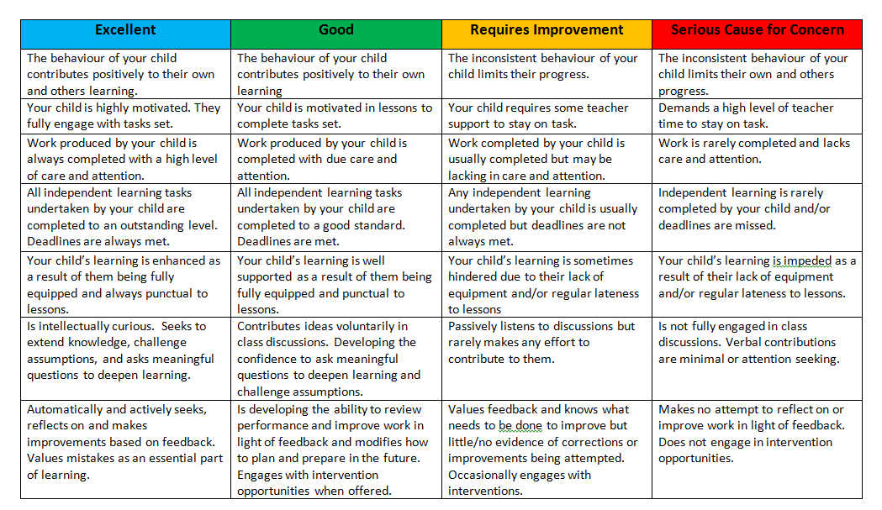
Attendance
Outstanding - If attendance is 100%,
Good - If attendance is equal to or greater than 96%
Requires Improvement - If attendance is less than 96%
Serious Concern - if attendance is less than 90%

Sample Student Assessment Report (SAR)

