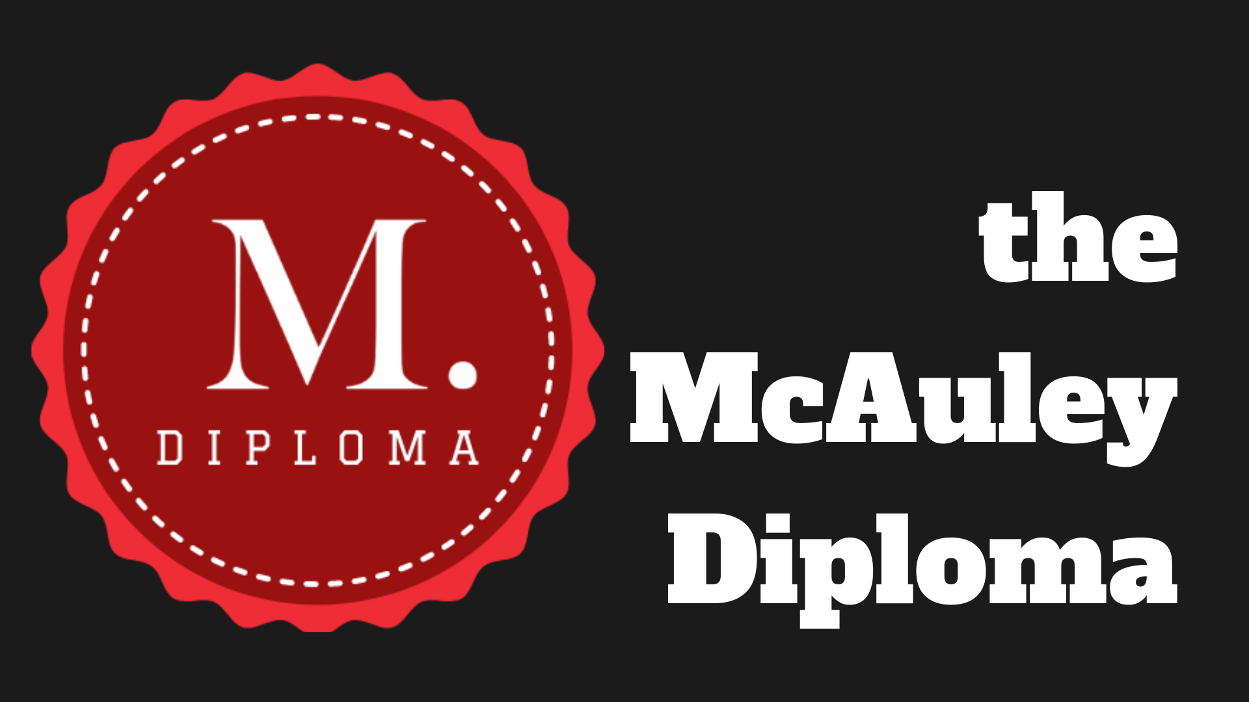


Briefing Document
2021
Rationale
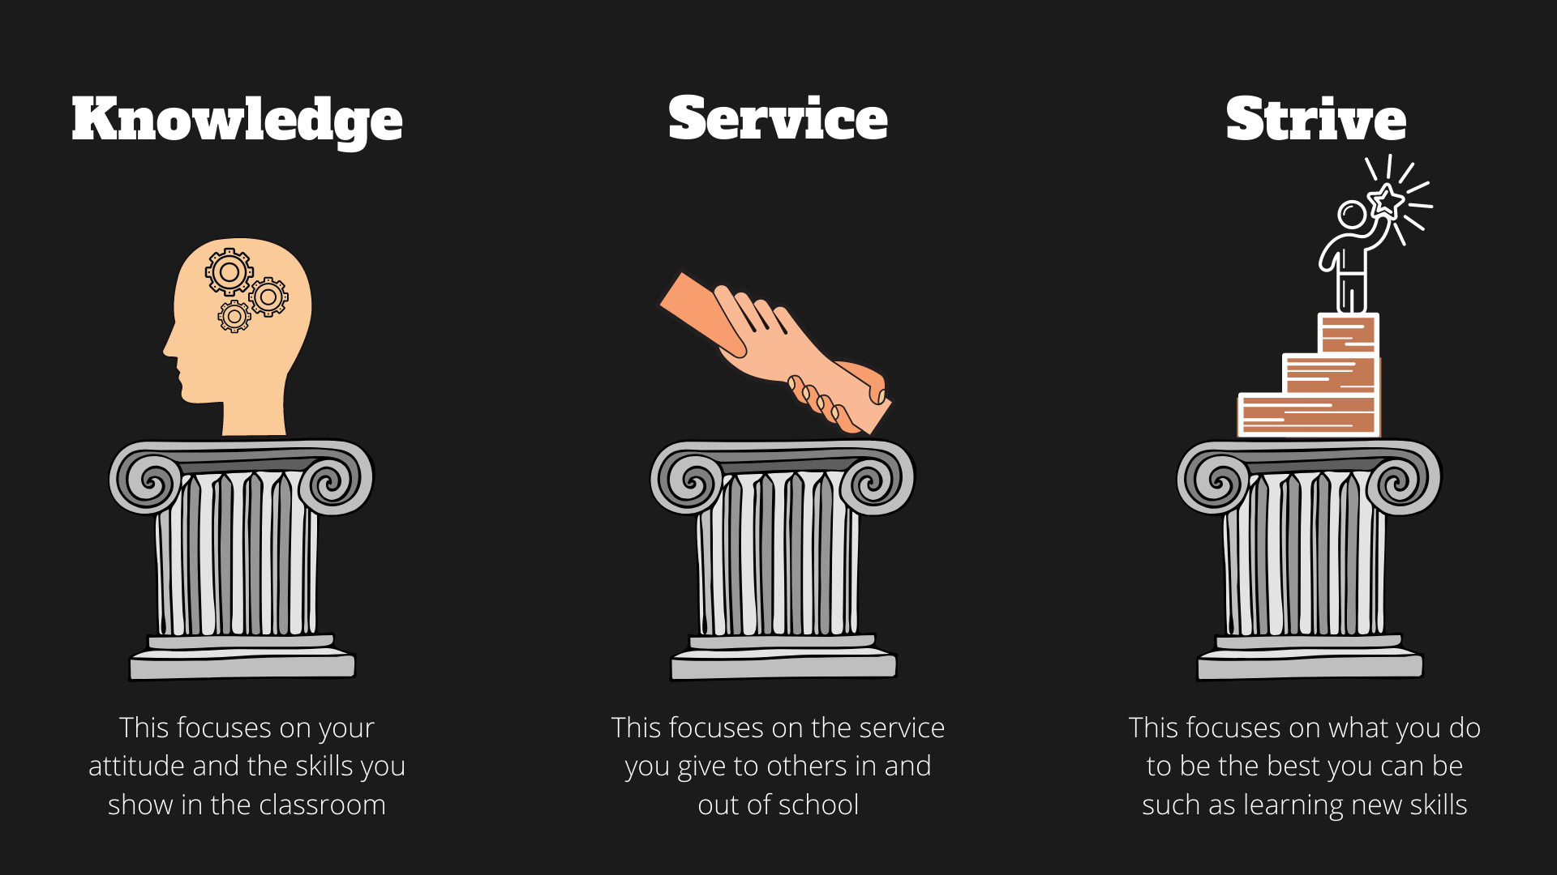

The purpose of education is not to make every child the same, not to come away with grades or numbers that over time will have less and less relevance to their adult life. It is to shape the and develop the child, to embrace all their gifts and talents and nurture them to their fullest potential.
We know there are many schools that will focus on an outcome, a set of results when your son or daughter is 16 or 18. But we are wanting more, our community will want more than that. With this in mind, we expect all students to fully commit to McAuley Diploma although all might not achieve it. The McAuley Diploma provides a tangible outcome for our students to achieve and will allow us to celebrate the successes of our young people as they progress through their education at our school.
We know and recognise that being a McAuley student means something more than simply attending our school. It means being part of something bigger, not just being a member of a school but part of a community. As such this diploma will celebrate this and your child to its fullest potential.

How does our Diploma work?
We have examined our school curriculum and wider opportunities of learning, service and leadership and we have also recognised the significant achievements that a student may undertake outside of school that impacts on their education. We have broken these down into three strands:
- Knowledge – The enhancement and application of knowledge. This is the first tenant of our school life. This is primarily done through the application of school data from the ‘attitude to learning grades’ we collected on a regular basis. This will be completed and used as an average for each subject.

We also note that we intend to also reward and note the skills students develop within the Core Ethos and Values Strand where we audit the ‘soft skills’ of communication, oracy, teamwork, listening, and their ability to work independently. No subject is left out, and the application of knowledge will be done through students auditing where they did this in specific pieces of work via assignments in Microsoft Teams.
- Service – This focuses on service that we do for others. This strand of the diploma can take many forms through student leadership, fundraising (in and out of school) supporting others i.e. buddies as well as simply being here, being a member of our community and taking a full role as a form rep or in Chapel.
We also strive to recognise that being part of school, being excellent in class and engaging fully in lessons is also setting an example for others as such we reward that through the attitude to learning focus. All this strand is completed by students applying evidence to their ‘Service’ Assignment(s) in Microsoft Teams. This can be done through copies of emails from teachers, photos, written reports by the students or by others or by awards – for example the Duke of Edinburgh Award.

- Strive – The final element of this diploma focuses on the understanding we want all students to strive, to achieve more than they first thought possible. We live in an age or limitless possibilities, where often resilience and adaptability mean just as much as what we learnt in previous years. As such we also reward those who are getting extra support – but only if they fully use these opportunities. We also ask students to use the extended learning projects to showcase their talents. Again, much like the service strand, this strand is completed by students applying evidence to their ‘Strive’ Assignment(s) in Microsoft Teams.

“An intelligent heart acquires knowledge, and the ear of the wise seeks knowledge”
Proverbs 18:15

Weighting Table- Key Stage Three and Four
Knowledge 1 | Knowledge 2 | Service | Strive
All subjects are graded equally via Attitude to Learning grades which are reported 10 times per year.  An average is taken for each subject and applied each year. | Points are given for commitment to the LLC (Life, Character and Culture) Curriculum via MS Teams work and other sessions. (10 Points)  Points are also given for students auditing of application of knowledge, ethos and values which asks students to provide evidence of ‘soft skills’ of teamwork, leadership, listening, oracy, and resilience | This strand is divided over three areas:  School Community examines any service completed in school – for example buddies, mentors, school helpers on Open Days etc. (10 points)  Wider Community explores and rewards service out of school in the wider community. (10)  Attendance is also added to this stream with above average attendance being rewarded. | Literacy & Numeracy Support (2.5 to 10 points) – this is dependent upon it’s impact on literacy and numeracy.  Extended Learning Projects – where students undertake opportunities to extend their learning (10 points).  Completion of ‘hours’ challenges. This is mainly geared towards to GCSE students (10 points).  Taking part in ‘Cultural capital’ challenges which promotes students accessing cultural opportunities such as visiting museums, galleries, plays etc (10 points)
  A2L Grade | Points
  4 (Excellent) | 10
  3 (Good) | 5
  2 (Req Imp) | 2.5
  1 (Ser Concern) | 0
How is the evidence provided?
Data taken from Sims – no input from students. | MS Teams assignments – evidence provided by the students. | MS Teams assignments – evidence provided by the students.  Attendance taken from Sims – no input needed from students. | MS Teams assignments – evidence provided by the students.  Hours Challenges collected via Sims – no input from students

At KS4 use to support NCS (National Citizenship Service)

Weighting Table- Key Stage Five
Knowledge 1 | Knowledge 2 | Service | Strive
All subjects are grades equally via Attitude to Learning grades which are reported 10 times per year.  An average is taken for each subject and applied each year. | Points are given for commitment to the LLC (Life, Character and Culture) Curriculum via MS Teams work and other sessions. (10 Points)  Points are also given for students auditing of application of knowledge, ethos and values which asks students to provide evidence of ‘soft skills’ of teamwork, leadership, listening, oracy, and resilience | This strand is divided over three areas:  School Community examines any service completed in school – for example buddies, mentors, school helpers on Open Days etc. (10 points)  Wider Community explores and rewards service out of school in the wider community. (10)  Attendance is also added to this stream with above average attendance being rewarded. | Mentoring other students (10 points)  Extended Learning Projects – where students undertake opportunities to extend their learning (10 points) as a formal qualification – this can include the completion of MOOCs (Massive Open Online Courses)  Completion of ‘hours’ challenges to support effective revision.  Taking part in ‘Cultural capital’ challenges which promotes students accessing cultural opportunities such as visiting museums, galleries, plays etc (10 points)
  A2L Grade | Points
  4 (Excellent) | 10
  3 (Good) | 5
  2 (Req Imp) | 2.5
  1 (Ser Concern) | 0
How is the evidence provided?
Data taken from Sims – no input from students. | MS Teams assignments – evidence provided by the students. | MS Teams assignments – evidence provided by the students.  Attendance taken from Sims – no input needed from students. | MS Teams assignments – evidence provided by the students.  Hours Challenges collected via Sims – no input from students.

Awards and Celebration.
How does the diploma work?
We will reward and award every year with year group diplomas.

Celebrating all our talents
The Diploma must seek to reward all student effort. Beyond the main qualification the Diploma would seek to push to recognise students’ achievements that illustrates those in our community to strive to make a difference.
Each element of the diploma will be given an ‘early’ reward to recognise the progress made.
- McAuley Foundation Diploma Level 1 – Year 7
- McAuley Foundation Diploma Level 2 – Year 8
- McAuley Foundation Diploma Level 3 – Year 9

- McAuley Diploma Level 1 – Year 10
- McAuley Diploma Level 2 – Year 11

- McAuley Extended Diploma – Year 12
- McAuley Extended Diploma – Year 13

